# 

## Stringing, Reconnecting, and Breaking the Colonial “Daisy Chain”: From Botanic Garden to Seed Bank

Xan Sarah Chacko

Wellesley College

xchacko@wellesley.edu

### Abstract

Transported through colonial technologies such as Wardian cases and imperial ships, or simply popped in envelopes and sent via the postal service, the reproductive bodies of plants have been extracted, commodified, reproduced, and proliferated to satisfy human needs and desires. The ongoing and historical movement of plants and their reproductive capacity—known now through the disembodied clinical term *germplasm*—for economic, social, political, and agricultural purposes provides a lens through which global fertility chains can be studied. I study one such fertility chain: the movement of seeds of plants into frozen vaults known as “seed banks.” While colonial plant movements are associated with exploitative control, newer plant extractions for seed banking are shielded from rebuke because they embody the unquestionably positive valence of “biodiversity conservation.” The view from Australia captures the awkwardness of seed banking as a reproductive technology because the ongoing tensions between Indigenous struggles and settler-colonial nation building, and the urgency around climate change, are far from resolved. The politics of the Anthropocene are particularly poignant in Australia because anthropogenic destruction looks very different when viewed from the perspective of either Indigenous people or settlers.

### Keywords

Colonial botany, seed banking, Australia, conservation, settler colonialism, botanic gardens

### Introduction

I arrived in Australia to start my research fellowship at the University of Queensland in late spring 2018. I was to make my home in the city of Brisbane—Meanjin in Turrbal1—with little expectation of familiarity: I had, after all, never lived in Australia. I discovered that I had been passively training for assimilation in Brisbane long before considering a job here. My senses had been attuned to particular cultural, social, and spatial forms simply by virtue of being from another former British colony. I was prepared to encounter the familiar smell of gum trees (*Eucalyptus*) that had been a part of my childhood at a boarding school in southern India, but what made this place even more familiar than I could have imagined, were the jacarandas (*Jacaranda mimosifolia*) that were all ablaze in their flame-blue flowers seemingly synchronized to my arrival (Figure 1). Seeing the pavements strewn with the telltale slippery traces of fallen purplish blossoms made me feel at home in those first weeks of finding my way around. It should not have surprised me that trees that I associated with my home were also prevalent in Australia: we shared the same subtropical humid weather, and, more crucially, the same colonial power had exerted control over both our botanic destinies. We shared a *natureculture*:an entangled human and more-than-human experience of being in the world (Haraway 1999, 25). I would have the same familiarity with the jacaranda had I lived in Johannesburg, Lusaka, Alicante, or San Diego. The tree’s preponderance is not only a testament to its striking, however fleeting, beauty, but also to the fertile botanic chains that have enabled a tree native to south-central South America to spread its roots around the globe in the last two centuries.

Trees, like the jacaranda, form enduring traces of a shared colonial past. Like monuments, cities, streets, or train stations names, they carry the memory of the violence and subjugation of coloniality. Trees chosen for particular ornamental or economic value and transplanted across similar climes come to occupy cultural value—sometimes pride, sometimes derision—in the new places they call home. Great efforts are made to secure (or curtail) the reproductive futures of plants, and studying the language and practices of botanic fertility chains illuminates the inherent eugenic and biopolitical logic of controlling reproduction—both plant and human.2 The breeding of plants to produce offspring that carry particular traits is considered logical and desirable. Two spectral presences in human reproduction, eugenics and miscegenation, are absent in the realm of plant reproduction where, uncoupled from their moralistic valence, it is wholly desirable to strive towards perfection in form through controlled sexual reproduction of compatible species across the globe. Moreover, keeping plants alive in order to continue the possibility of human life has been systematized through neoliberal concepts such as “ecosystem services” where more-than-human liveliness is translated into functional use in supporting human life (and capitalism). I study a fertility chain: the collection and transfer of seeds from instantiations of human-plant relation (like a farm, or the “wilderness”) into frozen vaults, sometimes far away, known as “seed banks.” This technoscientific enterprise has gained popularity in the late twentieth century amidst the twinned crises of the loss of plant life, both in numbers and kind, and the insecurity of food production in a changing climate. Seed banks with their imagined frozen potential are marketed as a solution that could save entire species of plants, and the entire species of humans through their value to agriculture, medicine, or industry.3 Recent studies from history, anthropology, and feminist science studies are thickening and troubling the origin stories (Fenzi and Bonneuil 2016; Curry 2017; Chacko 2019b), funding (Lewis‐Jones 2019), and politics (Peres 2019; Harrison 2017) of seed banking. This paper contributes to this emergent field the argument that even if contemporary conservation through benevolent international partnerships appears to be egalitarian and collaborative, in practice these relationships re-embed the colonial politics of collection and accumulation that characterized an earlier era.

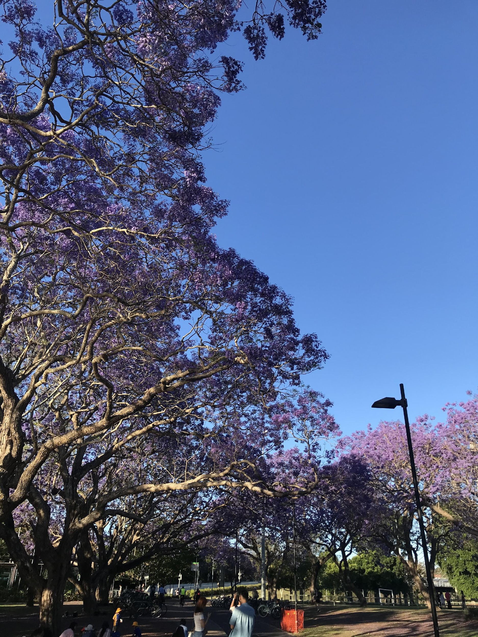

Figure 1. Jacaranda Way at the University of Queensland, 2018 (Photo by author)

Scholarship on assisted reproductive technology (ART) has shown that the disembodiment, movement, valuation, and transfer of body parts are part of a global value chain (Nahman 2008; Kroløkke 2018; Newman and Nahman 2020; Vertommen, Pavone, and Nahman 2021). At the simplest level of comparison, it is worth noting that the suspension of life in cryogenic stasis is at the heart of ART and seed banking alike. The ensuing problematic of temporal disruption, which Risa Cromer (2019) productively engages in a case where frozen embryos are imbued with personhood and thus thinking of them as property amounts to enslavement, also comes back to haunt historical collections in seed banks under changing regimes of international governance and intellectual property. In addition to being frozen, the very capacity for disembodiment, alienation, and circulation—far from the bodies that produced them—of both gametes and seeds, is an axiomatic unifying factor. Building on these initial comparisons, the global fertility chains—both human and plant—share another feature in that the direction of flow of value and body parts are skewed such that the Global South is overwhelmingly the provider of labor and bodies in service of reproduction, fertility chains are thus structured by geographies of uneven development (Vertommen, Pavone, and Nahman 2021). Susan Newman and Michal Nahman’s (2020) recent work, through the example of the first commercialized breast milk production from India to distribution in Australia, adds to this rich literature in both plant and human reproduction that fits this pattern of the flow of commodified care. The third node of comparison between the botanic and human global fertility chains pertains to the national and international governance that shapes the flow of value and labor. While the comparison between the global flow of plants and humans is more suited to studies of migration, “naturalization,” invasion, and settlement, the disembodied form in which seeds—technically understood to be fertilized embryos—are moved around the world and saved in frozen vaults makes for a reasonable point of reference to ARTs, which share the same technology and logics of disembodiment.

In this paper I dwell on the current struggles of a fertility chain of seeds in Australia that emerged out of the need to seek legitimacy for a key colonial institution—the botanic garden—in the form of the neoliberal seed bank. Even as changes in international regulations attempt to create avenues for justice through the distribution of credit and wealth in exchange for access to Indigenous plants, I argue that the replacement of long-term public funding with neoliberal competitive grants reprioritizes the focus of seed banking towards making more new collections instead of caring for the seeds that are already under their purview. I will show that the necropolitical decision to let collections of seeds die from neglect is an echo of the colonial violence against the Indigenous people from whose land the plants were, and continue to be, extracted. While colonial plant movements are associated with exploitative control, newer plant extractions for seed banking are shielded from rebuke because they are imbued with the unquestionably positive valence of “biodiversity conservation.”

Australia faces seemingly contradictory challenges when it comes to the future of plants, food, and agriculture. On one hand, since most of the crops grown and consumed in Australia come from plants and animals whose progenitors were imported, maintaining access to genetic diversity from outside Australia continues to be considered crucial to breeding new crops that can withstand the challenges of climate change. This explains the continued interest in “invited invasions,” like that of the jacaranda, into the Australian body politic (Cardozo and Subramaniam 2013). On the other hand, as the island nation comes into its own identity, Australia has long been self-fashioning as unique from its colonial roots, with specific ecological constraints and advantages. Biosecurity in the name of conservation has taken on a powerful valence because so many of Australia’s fauna and flora are not found elsewhere and are threatened—think koalas and bushfires. News stories with titles such as “Johnny Depp’s Dogs Face Death in Australia” are testaments to how seriously Australia takes its biosecurity (BBC 2015). Anthropologist Patrick Wolfe’s (2006) work reminds us to regard the anxieties about preserving uniquely Australian naturescapes as entwined with the purposeful, systematic, and ongoing erasure of the Indigenous people from the land. In addition, Emily O’Gorman and Thom van Dooren, thinking with philosopher Val Plumwood, state that Australian farms enact the policing of a border between nature and culture by continuing to eradicate (but always failing to do so) “wild” animals—understood as pests—because they do not fit the logic of settler-colonial mastery over the world—in this case, farm (2017, 2). I will show that efforts to capture and control botanic futures continue practices of alienation but do so under the valence of a universalizing greater, sometimes planetary, good.

I am inspired by the tripartite rubric of biological collection offered by Bronwyn Parry, which explores the dynamics of collection along three key axes: acquisition, accumulation, and regulated recirculation (2004, 15). This analytic is particularly helpful in following the flow and trajectories of collected botanic bodies as they pass through the fertility chain in time. Elsewhere, I write about accumulation through practices of concentration, purification, and care in seed bank laboratories (Chacko 2019a). Here, I focus on how acquisition and recirculation are caught in between differing cosmopolitics of human-plant relations because of how colonial durabilities reverberate across the botanical supply chain. This paper moves in three registers. I begin with the history of the Brisbane Botanic Gardens and follow the challenges and articulations of the processes of acquisition that it engendered in Queensland, Australia. I stay with the question of access, which is an increasingly fraught space of contention. Today, efforts made to keep native Australian flora and charismatic fauna alive stand in awkward tension with the necropolitical history of the elimination of Aboriginal life and the ongoing suppression of Aboriginal rights and dignity (Wolfe 1994, 2006). The imperative to collect was always juxtaposed with the projects of introduction. This dual flow of plant material out of and into the colony forms the basis of the botanic fertility chain. It served both as enrollment in the colonial botanic networks centralized from the Royal Botanic Gardens, Kew, England (henceforth Kew), as well as, enhancement of the political economy of the colony of Queensland.

In the second part of the paper, I track Australian botanic chains into the twentieth and twenty-first centuries to uncover how the newly formed Australian Seed Bank Partnership (ASBP), between the colonial actor Kew and a consortium of botanic gardens in Australia, created a patronage regime that shapes the stakes of collecting under the ecopolitical valence of conservation. Building on interviews with curators, scientists, administrators, I analyze the anxieties and troubles faced by these carers of seeds. Rather than taking the worlding practice of seed banking as unambiguously “good,” through opening up their concerns, I work to “slow down” an analysis of how institutions rationalize engaging in these neocolonial alliances despite having “the best intentions” (Stengers 2005, 995). I take inspiration from scholars who have questioned the value in postulating a universalizing concept of “ethics” or “dignity” in the flows of human fertility (Nahman 2008) to take seriously the intentions of those for whom what is at stake in reconnecting botanic fertility chains is nothing less than their institutional survival. In the final section of the article, I consider the changes in international regulations intended to provide justice to the “traditional owners” of “plant genetic resources.” I argue that the totalizing power of “climate crisis” and the neoliberal piecemeal funding model makes it easier, if not sometimes prudent, for scientists and administrators of historical collections like seed banks and gardens to sidestep responsibility towards reconciliation. Here, I think with and modify Carrie Friese’s take that “media spectacles regarding technoscientific making of zoo animals is meant to bring funding for the zoo” to make a similar case for botanic gardens, where participation in futuristic technoscientific enterprises like seed banking serves to generate additional sources of income (2013, 66). In light of the growing imperative towards reconciliation and recognition of Aboriginal rights, attempts are being made to think about the use of historic collections and making of new ones. How historical and contemporary biological accessions are collected, maintained, distributed, and used is both a legal and political live wire. Why then would botanic gardens across Australia maintain close collaborative ties and, in some cases, connect new links in global fertility chains with an organization, like Kew, famous for its role in maintaining extractive botanic relations? My contribution to the literature on colonial global fertility chains is to show what comes into clear relief when plants, rather than humans, are made central in the narrative of extraction, commodification, alienation, and neoliberal control. By paying attention to the history of botanic fertility chains that allow plants to be collected, stored, shared, and then left to languish in some cases, I show how the slow iterative violence (Nixon 2011) of endeavors like plant collecting can illustrate “imperial durability” (Stoler 2016) as an ongoing “structure not an event” (Wolfe 2006, 388).

### Stringing the Colonial Botanic Chains

Brisbane’s jacarandas were introduced in 1864 by Walter Hill (1819–1904), the first curator of the Brisbane Botanic Gardens (now called the City Botanic Gardens). Born in Scots dyke, Scotland, Hill was apprenticed as a gardener at the Royal Botanic Garden Edinburgh, before accepting a position in 1843 as the foreman of propagation and new plant departments at the pinnacle of botanical science, the Royal Botanic Gardens, Kew (*Journal of the Kew Guild* 1904). Much scholarly attention has been paid to both the processes of plant acquisitions in the colonial context (Schiebinger 2009; Bleichmar 2012; Osseo-Asare 2014), and the re-circulation of expertise in the form of administrators, curators, and botanists (Grove 1996; Endersby 2008; Schaffer et al. 2009). Starting with the jacaranda, it is the aim of this paper to examine the enduring logics of colonialism (Stoler 2016) that pervade the historiography of plant extraction (Parry 2004; Hayden 2003). The jacarandas and Hill are entwined in a fertile chain. After nearly ten years of working at Kew, Hill sought a position as the curator of the Cambridge Botanic Garden, for which he received a recommendation letter from the director of the Kew Gardens, William Hooker. Unsuccessful in this application and with little hope for upward mobility at Kew, Hill and his wife, Jane, migrated to Sydney on board the *Maitland* in October 1851. With skills in acclimatizing plants, and the experience of having worked at a focal node in the vast imperial network of botanic fertility chains, Hill was ready to be woven inextricably into the threads of the colonial tapestry. In 1855 he was chosen to be the first curator of the newly established botanic garden in Brisbane. More than five hundred miles from Sydney, Brisbane represented the northern outpost of the colony of New South Wales (Evans 2007). With land (nine acres) and a stipend (£500), Hill set out to acclimatize plants from around the world that might suit the subtropical biogeography of Brisbane.4 Jacarandas are just one example of this acclimatizing fervor (Osborne 2000) but have captured the public imaginary because of their striking color.

Perhaps one of Hill’s most famous plantings of jacaranda in the Brisbane Botanic Gardens was captured in the painting *Under the Jacaranda*, by R. Godfrey Rivers in 1903 (Figure 2). The painting shows two women and one man dwarfed under a magnificent jacaranda in full bloom. On close inspection, the painting reveals a familiar domestic scene of a seated couple taking tea served by a uniformed standing woman. Painted just three years after the independence of Australia, the painting captures two critical features of the settler colony: (1) living introductions (of both human and plant species) are thriving; (2) everyday social norms, hierarchies, and routines are not just maintained but flourishing. The towering purple-flowered tree is an icon of subtropicality, while the tea set is an anchor linking the space to Britain, via another crucial plant of the Empire: tea. The culture represented by the tea set makes the tree seem at home within the settled nation. While this iconic tree was blown down by a cyclone in 1980, the botanic garden continues to be a central site where the enterprise of early colonial history is made evident through botanic traces.

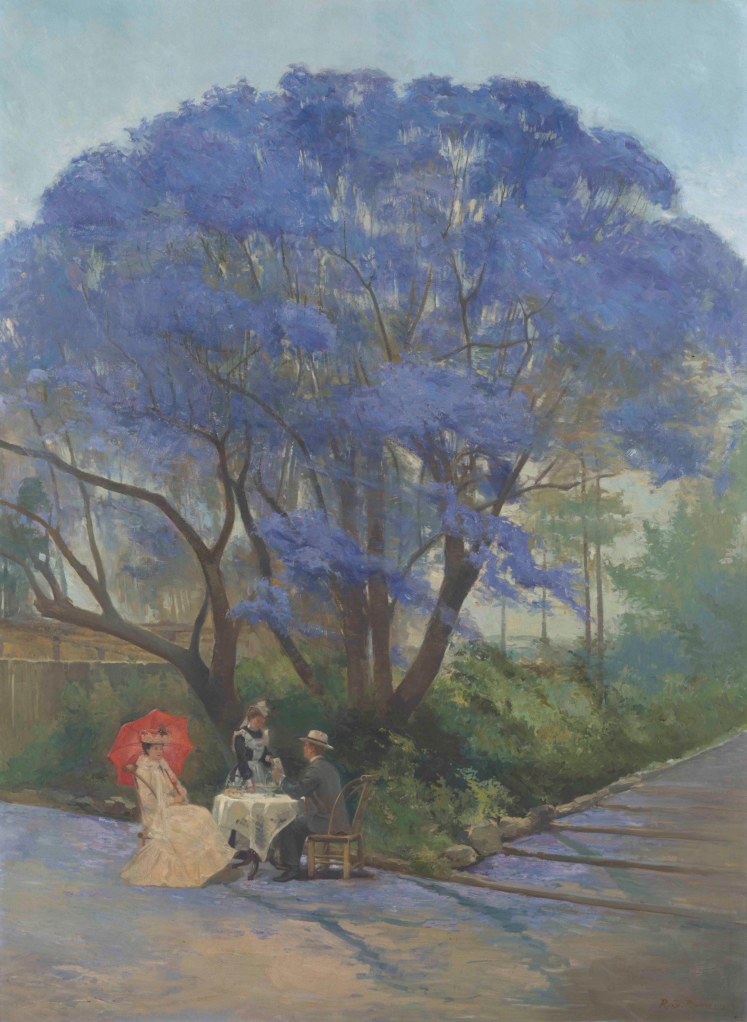

Figure 2. R. Godfrey Rivers *Under the Jacaranda* 1903 (Oil on canvas, Reproduced with permission of the Queensland Art Gallery, Brisbane)

Trees like the jacaranda were introduced to places far from their origins but are now a part of the fabric of the entangled postcolonial and settler-colonial experience. According to the website Environmental Weeds of Australia, the jacaranda was “naturalized” in 1987. Naturalization here signifies a moment of transition where an introduced “foreign” or “exotic’” plant is successful at self-propagation outside the nurturing influence of humans. The plant for the first time is freed from the chain of human control and is now regarded as natural. Ironically, much like new immigrants like myself, the jacaranda is so good at acclimatizing that it is now considered an “environmental weed” in New South Wales and Queensland. Much like the jacaranda, my temporary invitation to stay in Australia was contingent on my continuing to stay productively employed at the University of Queensland and I am reminded by the immigration permit issued by the Department of Home Affairs that my visa can be cancelled if I “behave in a way that is a risk to somebody in the Australian community” (Temporary Activity (subclass 408) Visa 2018). What little familiarity is gained from seeing oneself in the natureculture of a new place through trees must be recalibrated by the realization that we are, the jacaranda and I, both examples of “invited invasions” (Cardozo and Subramaniam 2013) that walk the line between exotic species valued for what they bring to a new place, naturalized species that are now “at home” but already weeds because they can never fully belong, and noxious weeds that threaten the body of the nation.5

Aside from the jacaranda, Hill is credited for having introduced the mango, prickly pear, ginger, poinciana, tamarind, and mahogany, and for coordinating expeditions to the coastal north and interior, bringing back plants that he thought would be of value, and pouring them into the Kew pipeline (Langton 2016, 236). Success for colonial naturalists was achieved not only through the extraction of useful or novel specimens out of the colony, but also in being able to show that they were able to acclimatize and profit from the plants sent to them from elsewhere. In 1858 Hill’s successful propagation of the macadamia, collected from North Queensland, within the Brisbane Botanic Gardens’ collection marked the onset of the tree’s commercialization and export. When Queensland separated from New South Wales in 1859, Hill was appointed to the position of colonial botanist, which legitimized his direct communication with Kew. Colonial metropoles disciplined contributors to the colonial botanic chain in the appropriate means of collecting, preserving, and transporting specimens (Chacko 2018; Endersby 2001). Only through the continued voyages and land expeditions which brought new plants to name, propagate, commercialize, and market could the colonial botanist add value to the imperial state and make contributions towards the nascent natural sciences (Schiebinger and Swan 2007, 2).

Achille Mbembe articulates the difference between trading post colonies and settler colonies as one of pure exploitation in the case of the former and “an extension of the nation” in the case of the latter (2019, 11). The botanical stakes are thus different in settler colonies. Colonial botanists, such as Hill, were tasked with managing the exploration of the place they now called home, what Staffan Müller-Wille calls “colonialism turned inward” (2005, note 10). North Queensland represented an unknown but latent landscape onto which the somewhat contradictory desires of exploration and settlement could be enacted. On one hand, Hill, as natural philosopher, was responsible for “discovering” many “new” plants that could be enrolled into the botanic chain, but as a colonial operative, he was also a central figure in the selection of 500,000 acres of land to create the vast sugarcane plantations of Queensland. Settler colonialism is not about just specific moments of collection, “invasion is a structure not an event” (Wolfe 2006, 388). Equally proud of his contributions in botany and economy, Hill sent a sample of the first sugar manufactured in Queensland to London in 1862, as a proof of concept that the colony could be a productive and fertile contributor to the empire (*Journal of the Kew Guild* 1904). The relationship between agriculture and botany is even more direct in settler colonial worlds as successful—commercial—farming was crucial to the survival of the settlers (Langton 2016, 224). Extracting Indigenous knowledge of the uses and toxicities of plants allowed settlers to create the vast agricultural industries of sugarcane, cattle, and sheep (Evans 2007; Franklin 2007, 120).

The idea that exploration and collection were necessary for survival reveals the necropolitics of the settler colony (Mbembe 2019; Kauanui 2016). The success of Hill’s missions of collection and expansion of arable land hinged on the alienation of plants and land from their Indigenous custodians. Scholars of the history of Australia have shown that early settlers benefited from the acquisition of Indigenous naturecultural knowledge, all the while eliminating life, both human and more-than-human, to make space for the expansion of the colony (Wolfe 2006; Langton 2016). In Hill’s obituary published in the *Journal of the Kew Guild*, an anecdotal story tells of a collecting expedition from Keppel Bay to Cape York during which most of his party of seven were killed by “the natives” (1904, 207). After describing in horrific detail the condition of one of the deceased, the obituary confirms that Hill and his unnamed Aboriginal guide were the sole survivors. The reason that Hill was spared death was not his bravery or marksmanship but his choice to collect plants alone and up a mountain rather than alongside the beach like the others. The value of the plants found is increased by the deaths of the white people who were sacrificed in collecting them. Missing in the record is any mention of the Indigenous people who were undoubtedly also killed by the expedition party. The description in Hill's obituary juxtaposes the naivete of the European naturalist against the purported savagery of the Indigenous people. On one hand, this story reifies the bravery needed in continuing to collect, knowing that it could be fatal, and on the other hand, the need to bring death to the Indigenous people first: for, if not swiftly delivered, death would surely come to the white settlers.6

While the historical record captures the accessions as plants in the botanical garden, and names the white settlers killed during the expeditions, it is silent on the question of Indigenous deaths. Mbembe writes about the subterfuges employed to exonerate the supposedly retaliatory violence perpetrated by white settlers against Indigenous people:

the crimes were deeds performed by lone-acting individuals, who themselves were racked with fear owing to the animalistic behavior and the extreme, barbaric acts of their victims, and were thus overcome by the threat to their lives posed by these savages; the horrors experienced by the colonized scarcely carried any weight as regards the misery they would endure when left to their own devices; what had been accomplished in the name of civilization (economic development, technological progress, schooling, health, Christianization, and assimilation) worked to offset the negative—and allegedly inevitable—effects of the colonial project. (2019, 127)

The historical record may be silent, but contemporary artist from Badtjala, Fraser Island, Queensland, Fiona Foley brings histories of violence and segregation of the Indigenous people into unassuming botanical sculptures that dot the public art landscape of Brisbane. Outside the Brisbane Magistrates Court, her sculpture *Witnessing to Silence* (2001) takes the form of a circle of long-stemmed lotus and paving stones that list the ninety-four sites of where Aboriginal people were massacred in Queensland: a botanic chain bearing witness to the violence of settlement. There is a second violence necessary to the creation of colonial botanic chains that is intertwined by the collecting imperatives of colonial botanists. This estrangement is coproduced in the mentions of Indigenous peoples in the botanic record as threats to collectors in the places the collectors sought new and useful plants for empire. The forced alienation of Indigenous people, under the guise of “protection,” from their naturecultures by practices of capture and incarceration haunts the history of Australia (Kidd 1997). The Indigenous human-plant relations that scaffold the ecology of North Queensland are neither recognized nor articulated within the colonial botanic chain save for mention of local guides who accompanied the expeditions. Marcia Langton (2016) has shown that Aboriginal communities in the Cape York Peninsula had extensive knowledge of plants, including complex uses, seasonal variations, and ecological relations, most of which were lost to them in the decades following colonization. Wolfe’s concept of the “logic of elimination” (2006, 387) explains the ease by which Indigenous lives could be sacrificed for the settler-colonial project of territorial expansion, but I am drawn to necropolitics as a means of understanding what comes after death. In this case, it describes the systems of Protectors, Superintendents, missions, and reserves created to manage Aboriginal life in the latter half of the nineteenth century. These structures were instrumental in the reduction of Indigenous people “to a state of pauperization and widespread malnutrition during the most violent periods of the frontier and increasingly so during the ‘pacification’ phases, when food and ration stratagems were implemented by the Protectorates as critical weapons in a war of attrition” (Langton 2016, 223).

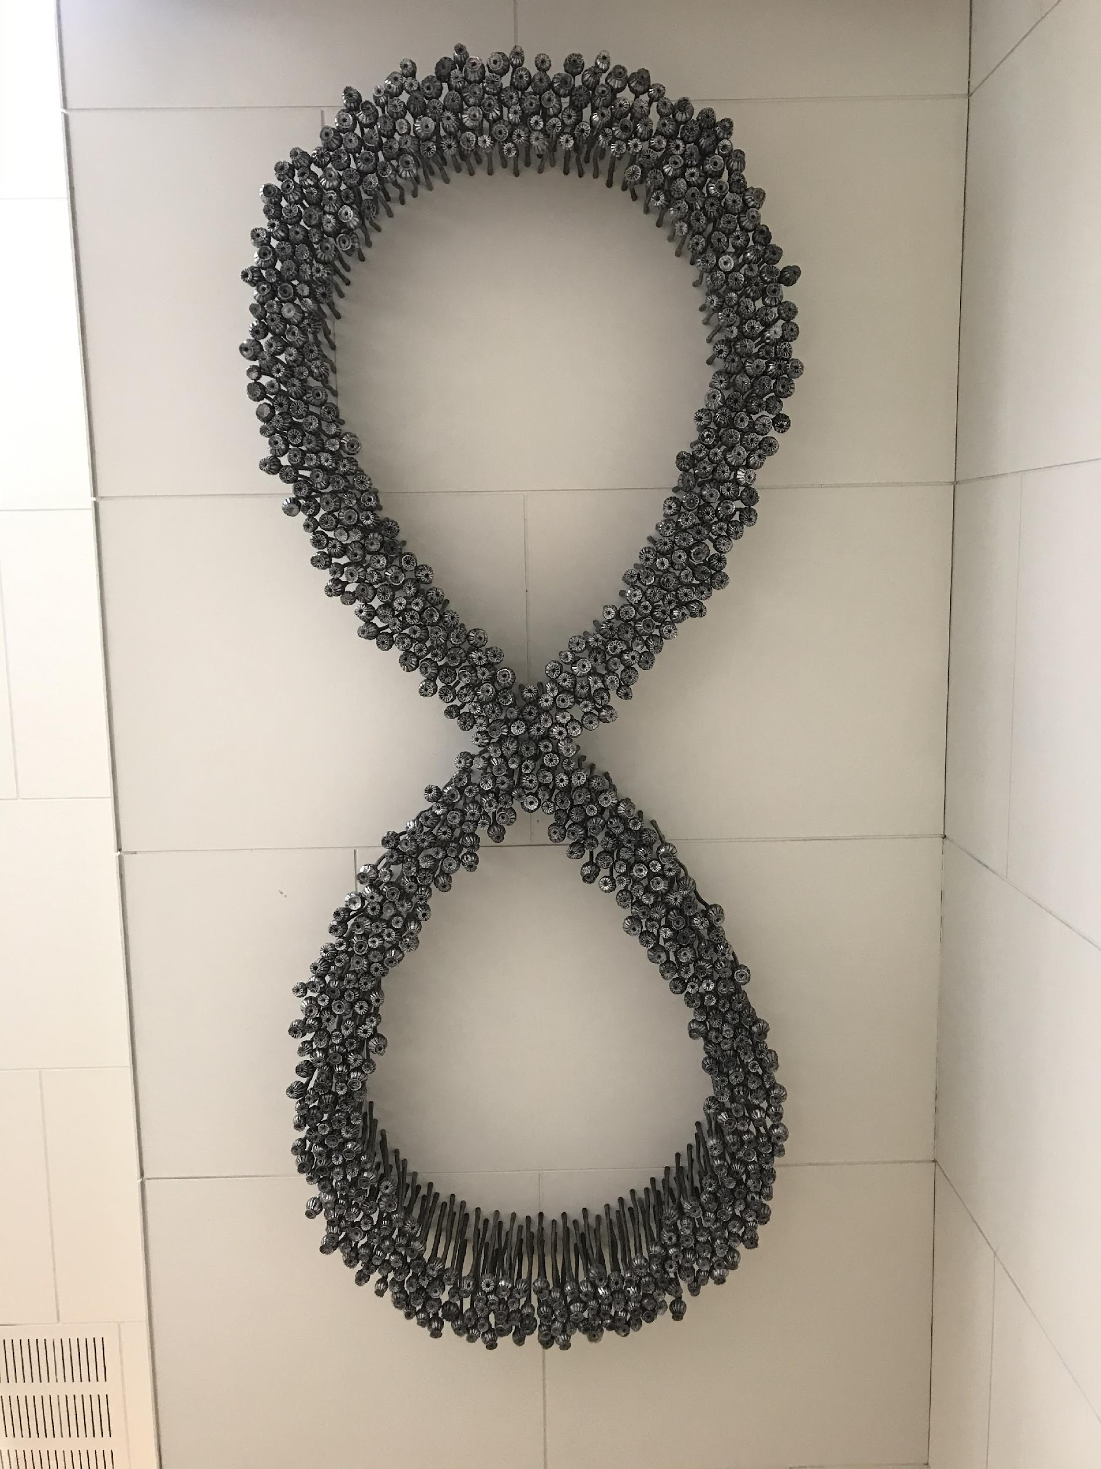

Figure 3. Fiona Foley, *Black Opium*,2006. (State Library of Queensland, photo by author.)

Here too, another of Foley’s artworks creates the possibility of bearing witness to the history of forced removals. The permanent installation into the ceiling of the State Library of Queensland, *Black Opium* (2006) consists of 777 aluminium poppy stems arranged in a figure eight: the infinity symbol (Figure 3). The unusual placement of the artwork has the dual effect of, at first, being rendered into the background, but on recognizing that it is visible from every floor of the library, it becomes a haunting presence that is impossible to ignore, getting bigger with each ascending floor. Through the symbolism of an infinity made of dark poppies, Foley references the ongoing, enduring, and brutal history of settlement in Queensland. *Black Opium* points specifically to the Aboriginals Protection and Restriction of the Sale of Opium Act 1897 and 1901, which was the legislation crucial to the creation of the system of Protectorates in Queensland, one of which, Bogimbah Creek Reserve, was built on Foley’s ancestral Badtjala land and became a “closed institution” of incarceration for any Aboriginal person deemed “unproductive or troublesome” (1897).Expanding on Wolfe’s statement that “invasion is a structure not an event,” J. Kēhaulani Kauanui writes, “settler colonialism is not simply a form of genocide” (2016). Instead, Kauanui argues that it is the alienation of the Indigenous people from land (through forced removals), knowledge (through re-education), and naturecultures (through controlled rations) that leads to “the elimination of the native *as native*.” As Bruce Pascoe (2014) has convincingly argued, the idea that Indigenous people were not aware of or intentionally relating to the non-human life in Australia is contradicted by the first-person narratives of the early white settlers who themselves described and benefited from the agricultural practices of the Indigenous people they encountered on their expeditions. It matters that the historical, anthropological, and archaeological records have difficulty with recognizing Indigenous practices of more-than-human relating as “agriculture” in Australia, because doing so serves the rationale of settler-colonial “civilization” and “progress.” The narrative of “discovery,” the valorization of being first to find, use, and make meaning of, which bestows the privilege of naming—and today owning—is incompatible with a cosmopolitics that recognizes Indigenous knowledge and custodial relations with the more-than-human (Blaser and de la Cadena 2018).

Even contemporary forms of political redress and reconciliation fail to imagine liveliness outside the Western paradigm. A case in Queensland (*Mabo v Queensland 1993*) initiated the changes to the Australian common law doctrine (Native Title Act 1993) that recognizes Indigenous Australians (both Aboriginal Australian and Torres Strait Islander people) have rights and interests to their land that derive from their traditional laws and customs. In practice, the effect of Native Title Act has put the onus of responsibility to prove connections to country on Indigenous people. This process instrumentalizes anthropological and archaeological evidence derived from the extractive practices of settler-colonial history, which had led to the impoverishment of Indigenous people in the first place (Wolfe 1994). Scholars have argued that the success of Indigenous communities in being able to mobilize the Native Title Act to gain mainstream recognition of their rightful relations with land is a false victory because it serves to legitimize the settler-colonial nation’s authority to bestow rights to those for whom sovereignty was never ceded (Foley 2020; Wolfe 1994). In the next sections, I follow the (dis)similarities between colonial botanic chains and current-day ones, which requires a theoretical reorientation to a new frame of reference around global unity against the threat of climate change, held in tension with an increasingly nationalistic and proprietary regulatory landscape in the extraction and use of plant bodies.

### Reconnecting Broken Chains

The story of Brisbane’s botanic gardens (there are now three) is not unique. The patterns of settlement in Australia can be matched by the creation of botanical gardens throughout the fledgling colony (Sydney 1818, Hobart 1818, Melbourne 1846, Adelaide 1855). They were, after all, important grounds to test the viability of a settlement. Through the twentieth century, each garden has continued its operation of acclimatizing foreign plants while showcasing ones found and made symbolic of that region. A lot has changed for the gardens and their role in the botanic chains. While they no longer occupy a pivotal role in the economic botany of a state, gardens continue to be the arbiters of taxonomic knowledge while remaining as iconic reminders of a more genteel era. Now, agribusiness companies —like Mitsui & Co. (grain) and CSR Sugar—and public breeding programs —like the Grains Research and Development Corporation—are responsible for the majority of the plants introduced into commercial agriculture so the botanic gardens in Brisbane do not wield the same political power or attract the same funding they once might have done. Recognizing their role in creating the unequal distribution of wealth through economic botany, garden administrators along with international organizations such as the Food and Agriculture Organization of the United Nations came together to create international regulations to address how value and remuneration are afforded in botanic fertility chains. These regulations are the Convention on Biological Diversity (CBD), 1993, that endows nations with sovereign ownership over the living beings within their borders, and the Nagoya Protocol, 2014, which requires the negotiations of consent and benefit sharing when extracting organisms for use in industry. In the case of settler colonies, these regulations must be seen as a resurgence of “biopolitics” (Foucault 2003) from their necropolitical roots. The creation of value around the intellectual property of botanical knowledge and specimens has had confounding effects. Some proponents claim that the granting of patent and varietal rights is an incentive to innovation in agriculture, while others show that the rights-based regime restricts access to living things and thus has a chilling effect on scientific research (Chapman and Heald 2020; Jaffe and Lerner 2006). In addition, since the prime movers in the space of agriculture are not governments but corporations, it has been extremely difficult to implement these regulations with any noticeable effect.

When their influence in the economy of plants reduced, gardens had to innovate in their collaborations and activities to stay alive. More and more, they have come to rely on relationships with partners—like Kew—to sponsor collecting expeditions under ever tightening rules of acquisition. Unsurprisingly, the relationships between Kew and each of the gardens have changed to reflect Australia’s proprietary claims, as a party to the CBD, over the living things within its borders and territorial waters. Kew has continued to have ties not only to each local garden but also to the idea of a national garden, evidenced at the moment of inauguration of the Australian National Botanic Gardens in Canberra in 1949, when both Prime Minister Ben Chifley and director of Kew, Sir Edward Salisbury, shared the role of planting the first trees.

The colonial ties remain even today, but instead of whole plants transported in Wardian cases on imperial ships, today the flow of parts of plants, such as seeds, can be a bureaucratic nightmare. Anxieties around biosecurity breaches (Straight 2017) and fears of biopiracy of sovereign property have made it very difficult to move plants across borders. However, the valence of new collection and circulation is less overtly about imperial control and capitalist expansion but is couched in the language of survival and “biodiversity conservation.” In addition to their traditional practices of collecting and acclimatizing plants, in the latter half of the twentieth century, many gardens have taken up the practice of banking seeds that they do not want to propagate for lack of space or to minimize the cost of maintaining living collections (Chacko 2019b, 3). Leading the charge to recognize Australia’s uniqueness and the value of “primitive cultigens or land races” was plant geneticist Otto Frankel (1900–1998), who advocated the importance of safeguarding diversity through seed banking for the “as yet unknown” future (1970, 476). Frankel’s call to conserve seeds for the future was motivated by a belief that future science would be able to use this reservoir in their enhanced “precision and scope for identification and transfer of genetic elements” (470).

At its core, every seed bank has a freezer, where seeds are stored for longer than they would naturally stay dormant, but in practice, each bank has its own logic for choosing what seeds to save, and what protocols to follow in preparing and maintaining frozen collections. In England, Kew had started placing seeds in cold storage in the 1960s. By the turn of the twenty-first century, they leveraged their experience in freezing seeds with the international awareness about the loss of plant life and diversity into a new facility that both renewed their commitment and cemented their position in leading the charge to safeguard the future of plants (Chacko 2019b). It was originally called the Millennium Seed Bank (MSB) Project, with a prime directive to bank the entirety of the known flora of the United Kingdom. Recognizing quickly that once that project was accomplished, the expansion of collection could only extend beyond the bounds of the nation-state under carefully negotiated agreements, the project was renamed the Millennium Seed Bank Partnership. Recentering collaboration in the naming of this facility is purposeful and understood as a political strategy that reopens access to the world, under presumably more egalitarian conditions than in the colonial era; this is what the CBD and Nagoya Protocol were designed to accomplish. The Partnership—now in ninety countries—strengthened ties between Kew and gardens around the world, ties that had been loosening since their colonial binds were no longer controlling the flow of plants. The new alliance offered three crucial incentives: (1) funding to make new collections in partner organization countries; (2) technology and training in the “correct” ways of collecting, sorting, cleaning, shipping, and organizing collections; and (3) access to the MSB vault in England as a space to store a duplicate of each new accession as a back-up collection. The spirit of partnership that underpins these offers and incentives to gardens and other flora-focused organizations in former colonies should not, however, be confused for altruism; it can be more accurately characterized as a form of paternalism. Each of the incentives links current practices of seed collection and banking to the forms of patronage and credit offered in the past to sustain the colonial botanic chains (Endersby 2008).

Damien Wrigley is the national coordinator of the Australian Seed Bank Partnership (ABSP), an institution created to consolidate Australian interests and efforts in seed banking across botanic gardens. Damien explained that between 2002 and 2010, as seed banking was picking up steam in the larger gardens, the only guidance they received was from Kew.7 Since negotiating agreements between each of the banks was rather cumbersome, Kew’s leadership suggested to the Australian government the creation of a partnership across the gardens pertaining specifically to their frozen collections; they already have a super organization for botanical gardens called the Council of Heads of Australian Botanic Gardens. Aligned with Kew’s strategic scientific plan, this partnership could be the focal point for the negotiations of access to seeds for safeguarding in the MSB’s vault. In 2011 the newly formed partnership created their own business plan (ABSP 2011) that formalized the network of nine seed banks and three related organizations, in their own words, “bridging the gap between policy makers, researchers, seed collectors and on-ground conservation and restoration activities” (ABSP, n.d.). Reinvigorating the impetus to collect, thicken, and redistribute (Parry 2004) is a newfound rationale that takes for granted that “seed banks provide a future-proof insurance policy for Australia’s unique flora, which is especially important in times of environmental stress” (ABSP, n.d.). This strategy works in two specific ways. First, the rhetorical power of threat and risk from unknowable future perils are mobilized to legitimize practices that have been ever-present in the history of the colonial project. By prefiguring the hazards of the future, the insurability of flora becomes a question of survival for all. The quickening pace of the climate emergency adds gravity to the need for expediency. Stalling this project with tedious bureaucracy is tantamount to inviting death not just for some but for the whole nation and indeed all of humanity. Second, using the Australian uniqueness of Australia’s flora to motivate the united front of the partnership conveniently effaces the question of Indigenous custodianship. Making natureculture national conforms to the sovereign ownership clause of the CBD (1992, 4) and justifies the exploitation of Indigenous people and land for a national cause. Consequentially, the responsibility for safeguarding native flora becomes a patriotic imperative for all Australians, irrespective of traditional relationship to country.8

Since the establishment of the Australian partnership, which was designed primarily to smoothly reconnect the continent’s flora to Kew, collection has proceeded along the guidelines set forth in the *ASBP Business Plan* (2011). The plan prioritizes the collection of plants that are endangered, endemic, and economically significant. In our interview, Damien confessed that the third criteria for selection was the one about which he felt least secure because the knowledge of the uses of “wild” Australian plants is, in his words, “missing.”9 When pushed to consider the Indigenous relations that generated this knowledge, he capitulated to a tired but prevalent argument that through the centuries of forced alienation from the land, newly recognized traditional owners of the Indigenous plants of Australia might themselves be alienated from the traditional knowledge of their ancestors, and that only science could rediscover utility in the flora of Australia. Each seed bank conducts collecting expeditions with funding, training, and protocols of collection from Kew, and in return the banks send a duplicate set of accessioned seeds to the MSB. Each bank uploads information gathered with each collection to a national registry that does not afford flexibility in terms data fields, so even if there were Indigenous knowledge, there is no place for it in the systems of data that accompany the journeying seeds.

As Parry has shown, the reduction in public funding to institutions like gardens, museums, and university departments of plant sciences has forced them to entreat alternative sources of funding just to continue to employ their staff (2004, 129). Limited by the remits of discrete funding proposals, seed banks find themselves having to meet a majority of their financial needs from these short-term goal-oriented contracts. In the fiscal year 2017–2018 the ASBP received funding from the Kew for four grant-funded projects, some of which had been going on for five years, totaling nearly $430,000, which amounted to 87 percent of their total income (ASBP 2019). The next year, the funding period being over, no new funds were received, and the income of the ASBP shrank to just over $3,500. However, since the projects were not yet completed and promises to funders could not be broken for fear of future repercussions, the partnership incurred a deficit of $212,000. Fortunately, unspent funds from the previous year could cover the expenses, but what about the future of the Australian collections? Missing from the promise of long-term security of seed banks is funding to provide care for the future lives of the humans, seeds, and databases that come together to form the seed bank world. The need to create back-up collections at the MSB is therefore a result of their denial of long-term funding to partners who facilitate collection and house local collections.

### Breaking the Fertility Chains

The precarious and sporadic funding model is not unique to the Australian seed banks (Kloppenburg 2004, 42–44). The competitive and piecemeal style also describes the funding model for large seed banks, including the MSB Partnership (Lewis‐Jones 2019). How can the commitment to reinvigorating fertile botanic chains be understood within this logic of scarcity? Over coffee, under the shade of a flowerless jacaranda at the University of Queensland, experienced agrobotanist Bruce Pengelly shared his feelings about the abject future of seeds in cold storage in Australia.10 Bruce was the curator of the Australian Tropical Crops and Forages Genetic Resources Centre for nearly twenty years, and in his retirement from institutional employ conducts reviews of seed bank facilities around the world. Bruce lamented the unpredictability and discontinuities in funding for securing collections of frozen seeds, denouncing “novelty” and “changing the world” as determining factors in the eyes of those who controlled the funds. He said, “We are forced as a genetic resource community to go for these one-year, two-year grants, and then move on to the next one. After thirty years of doing that, *it doesn’t work*! You are living on the minimum: it’s like feeding people to stay alive and not to grow. So all you are doing is just staying there.” After pausing for effect, Bruce concluded, “There has to be a time where you say *stop!*” Bruce thumped his fist on the coffee table, sending cups clattering and startling a nearby ibis that was hoping to scavenge the last piece of carrot cake from my plate.

I, too, was taken aback but was unsurprised by Bruce’s fervor and anger. Plant scientists often get excited and animated when it comes to saving seeds, and Bruce’s poignant portrayal of the slow violence of letting collections die through neglect brought another example of the effects of the piecemeal funding model (Nixon 2011). Bruce agreed with my observation that there always seems to be funding for making new collections but not for the maintenance of what has already been stored. Having argued in front of committees at the state and federal level, Bruce corroborated my suspicion that the gendered care work that is required to have any confidence in the viability of long-term storage is unsupported because it fails the litmus test of immediate results. Securing seeds for the long haul is exactly that: slow, long and, ideally, boring. Friese (2013) provides helpful language to understand the vagaries of funding that prioritizes “spectacular science,” that gathers public attention and provides newsworthy success stories, as opposed to “basic science,” which promises nothing more than the continuation of slow, incremental, and unremarkable achievements. What surprised me was Bruce’s solution for resolving this conundrum. He went as far as saying, “if we can’t work [funding] out in the next five years, we need to make the decision to *burn it!*” (emphasis mine). And just in case I had not fully grasped the gravity of his proposal, he banged his fist on the table again. This time I laughed, sure that he was joking. But after the people on the nearby table threw me nervous glances, I realized that he was deadly serious. Noticing that he had piqued my interest, Bruce explained that the strategy of at least threatening to destroy entire collections could be the only hope to mobilize long-term funding. I asked what would happen if his bluff was called, but he was resolute: curators would finally have a definitive answer. For Bruce, letting collections slowly die from neglect was far worse than the quick death of incineration. The indignity of having to beg for funding to maintain what to him is a priceless collection betrays shortsightedness in biopolitical governance.

Perhaps this most violent action of irrevocably severing the botanic chain by incineration is not the only option. Could the plants instead be “rematriated” to the communities from whence they came?11 Charlotte Kroløkke (2018) writes about how body parts considered waste to some but useful to others provide insight into how power in ART is distributed along national and institutional lines. Risa Cromer uses the example of remaindered embryos that are being “saved” by removing them from the freezer; she suggests that relegation to the freezer is not automatically what people mean when they intend for a collection to be saved (Cromer 2018). What if, rather than incineration, “saving” meant to thaw and release back into a natureculture that was willing to reintroduce the seeds to soil?

To Bruce and other administrators of “genetic resources,” a nexus of scarcity and loss amplifies the value in the collections. Many seeds in cold storage across Australian facilities cannot be re-collected or repatriated because the worlds they called home no longer exist. Some of the plants have been made extinct or come from environments that would not be able to host them anymore. Friese (2013) thinks about whether animals that have been brought back from extinction or “de-extincted species” are the same as the ones that roamed the earth before the extinction event. With the seeds there is an argument to be made that by taking the specimens out of their “time” and “place” and suspending them in relative isolation from their habitat, creating the conditions of their survival that are entirely human driven, we are in fact creating new species, albeit dependent on humans and less ecologically networked ones. In addition, Deborah Bird Rose and Thom van Dooren (2017) offer mourning as a praxis of coping with extinction rather than the “do something” fervor for de-extinction. They charge us to take the Anthropocene seriously but not pretend that we, as individuals, can do anything about it. Extinction is already a reality. I find it helpful to juxtapose these considerations of extinction with the ongoing struggle to imagine and claim the survival and endurance of Indigenous people despite the best efforts by the settler-colonial impetus to eradicate through enduring violence and toxicity (Hoover 2017).

Seeds in frozen vaults are examples of what philosopher James Griesemer (1990) calls “remnant models”—objects that represent living things but are also examples of them. As material entities that are products of the natural systems under study, these seeds are endowed with the agency to speak for entire species of plants for which there are no “real” counterparts. They are productive fictions representing a natureculture that no longer exists, and the responsibility for preserving them takes on biblical connotations. The desperate valence of this salvage project is not an accident. At a time of political and climate turmoil, seed banks try to leverage the fear of our own extinction into funding the future safety of frozen seeds.12 The limited success of this strategy speaks to a fundamental difference between seed banking and other forms of cryopreservation. While some kinds of biobanking require high initial investments in creating the facilities and securing access to the parts of living things, once banked, the collections are considered safe and inert (Radin 2017, 74). The seed banks are like other “germ” banks that take for granted the expectation that the seeds in storage, once thawed will be able to germinate, flower, pollinate, and produce new seed. All such stock centers require constant monitoring, reproductive labor, and testing. While protocols vary based on the seed bank, the guidelines put forward by Kew, as used in all the seed banks for the ASBP, involve testing samples of seeds from each accession every five years. The monumental human labor required to test the hundreds of thousands of accessions is ever increasing with each new deposition. Despite the reality that each new accession to the seed bank will also require this exponential labor investment to be secured in perpetuity, a purposeful blindness on the part of funding bodies relegates maintenance work to the profoundly unfundable when compared with the potential latent value of new collections.

The final piece of the complex puzzle in Australian seed bank worlds is the awkwardness that still remains relating to the reconciliation of historical collections. The CBD’s recasting of plants growing in Australia, even those such as the jacaranda that were introduced by Walter Hill, as the sovereign property of the state is a gift to scientists in Australia. Previous botanic flows brought many plants that have thrived in their new surroundings, creating the hybrid natureculture of the settler state. However, a new regulation to govern the use of seeds still maintained as latent resources threatens to reopen colonial wounds. The Nagoya Protocol Directive on Access to Genetic Resources and the Fair and Equitable Sharing of Benefits Arising from Their Utilization, which came into force on October 12, 2014, took on the mantle of access and benefit-sharing by making it easier to predict the conditions for access to genetic resources from a place of origin and by ostensibly providing a clear articulation of how these “genetic resources” would be researched, developed, and monetized in the future. For seed banks, the Nagoya Protocol, taken together with the CBD, has different kinds of effects. Since the CBD has been in effect, collectingplant material outside Australia has required adherence to the laws of the countries of the plants’ origin. However, in order to develop or conduct research on historically banked seeds, compliance with Nagoya depends on the interpretation of the language of the protocol. The opinion that serves the interests of users of the historical collections is that only materials *collected* after the date that the protocol came into effect would be regulated rather than new uses of historical collections. However, some countries, such as Norway and South Africa, have taken an extended view that even new use of historically collected materials are under the purview of the Nagoya access and benefit-sharing scheme (Sherman and Henry 2020). This would mean that material brought through colonial botanic chains would need to reconnect the ties that were broken by the alienation of colonial extraction. It remains to be seen if this will be the success in redressing the inequalities of the past for which justice-oriented feminist science has been yearning. Unlike for colonial botanists who generally needed the whole plant to do anything useful, the new needs of the biotech industry can be met by disembodied parts of living things, such as DNA sequences. The reduction to parts of living things has a confounding effect in the efforts to trace the origin and consequently to rethink ownership or rights (Parry 2004, 100–01). As Parry shows, despite the challenges and reluctance of Indigenous communities to participate, the practice of collection has continued through changes in the regulatory regimes (103).

Tracking the journeys of the digital fertility chains is the next logical step of inquiry (Leonelli 2016). This tracking involves finding the salient biological information as well as the bureaucratic traces of permission slips, agreements, and consent forms. In Australia, the recognition of Indigenous rights and ownership of traditional knowledge has changed the protocols used by gardens and banks to collecting from Indigenous territory. Nowadays, care must be taken to negotiate Access and Benefits Sharing Agreements and Prior Informed Consent must be received from the traditional custodians of the land before any collection is attempted. In interviews with garden, seed bank, and herbarium managers, it is made clear to me that that while they are sympathetic towards past injustices towards Indigenous people, the arranging of these agreements levies an administrative burden that they can ill afford. The alternatives are to collect on state-owned land where, at least in Queensland, Standard Material Transfer Agreements and permits are de rigueur, and on private land where negotiations with owners can be transactional. When there are workarounds that can circumvent the need to engage in delicate relations with Indigenous communities, the logical and fiscally prudent decision is often non-engagement.13

Whether by choosing to collect on state-owned land or by partnering with a country that has not enforced the Nagoya Protocol, botanical collection is possible for those who can gain funding, and cleverly avoid spaces that require burdensome paperwork. North Queensland is again the focus of one such collection project: the search for wild rice. A recent expedition from the University of Queensland sought to find grasses related to rice, to better understand how they have adapted to the hot swamps that characterize the area (Hamilton 2015). Neither seeds nor whole plants were the aim of this collection—just leaves—for that was all the scientists needed to characterize the specimen’s genetic relations and value. Collecting only on government land and with the appropriate permits seemed to satisfy the researchers ethical obligations. After all, the Nagoya Protocol has not been ratified by Australia in part because it has not yet been determined how the different state and local actors will interpret the historical use clause. The idea that the land was never ceded to the state from the Indigenous people could not be entertained because it would have paralyzed the university’s ability to continue its research. It should not surprise me to see how easy it is for the best intentions to fall away when threatened with inconvenience.

### Conclusion

In late 2020 my “invited invasion” to Australia ended in an anxious flurry of COVID-19 driven diplomatic and bureaucratic actions. My visa had expired, but I had to wait for a government repatriation flight as the commercial flights to India had been cancelled. The upside of the delay meant that just before I left, as a perfect bookend to my stay in Brisbane, I got to see the jacarandas bloom again (Figure 4). In this paper I introduced, situated, and narrated the history of a botanic chain in which I am intertwined through my life as a postcolonial subject, and my study of botanic gardens and seed banks. In slowing down how these chains were created, broken, and reconnected according to changing regimes of biopolitical control, I learn how to interpret the language of international regulations that attempt to move in the direction of recognizing Indigenous knowledge, traditional ownership, while at the same time, take on goals of “biodiversity conservation.” I have argued that many seed banks are not equipped to care for seeds in the long term (let alone the immediate future). Instead, seeds in vaults carry the necropolitics of slowly dying due to lack of long-term funding for their care, echoing the ongoing colonial violence and neglect endured by the Indigenous people from whose land the plants were, and continue to be, extracted. Juxtaposing examples from my fieldwork with seed bank carers and the art of Fiona Foley (Badtjala, Fraser Island), I have shown some similarities and differences between the global fertility chains that pertain to human and botanic reproductive histories and futures. While valuation and commodification are easily achieved with regards to plants, questions of future and historic ownership and control are fraught spaces of dispute and agitation. I clarified some attempts being made to address the unequal distribution of power in the collection and commodification of plants through a platform of distributing justice. But as I have shown in the previous section, workarounds and loopholes allow extractive business-as-usual to continue unhampered. To slow down is construed, at best, as an annoying hindrance to the progress of science and, at worst, as a denial of the crisis of climate change and food (in)security.

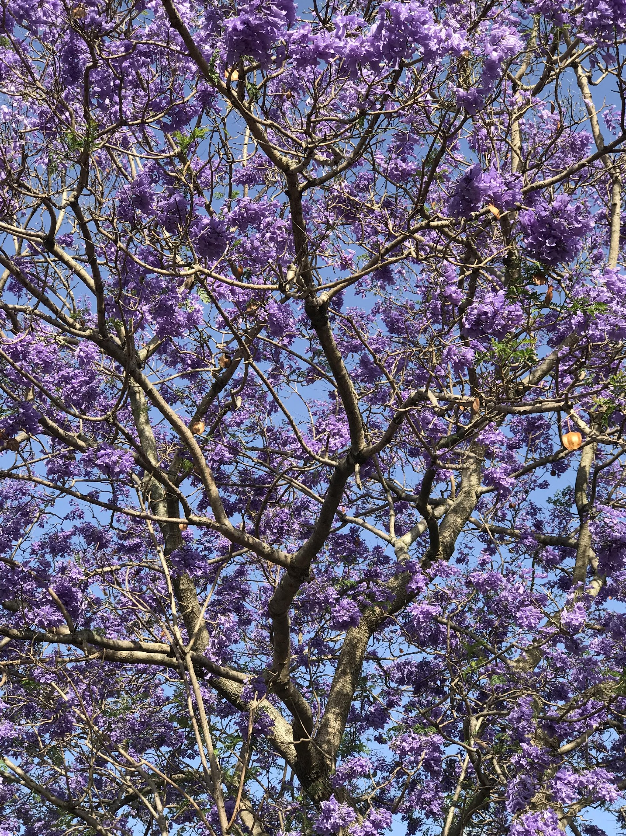

Figure 4: Under the jacaranda,2020(Photo by author)

### Notes

1 Turrbal is the Aboriginal Australian language and also the name of the people who are the traditional custodians of the region that comprises present-day Brisbane, Australia. The place, Meanjin, is also interchangeably used to refer to the people.

2 For an example of the interoperability of plant parts from around the world for the purpose of controlling the political economy of plants, see Saraiva 2019*.*

3 Cromer, Hardin, and Nyssa (2020) write about how “saving” as an ideal is cropping up in a diversity of spaces of concern.

4 Nine acres was a lot of space to be governing and £500 was a sizable fund. For reference, in 1941, the Royal Botanic Gardens, Kew was fifteen acres and its director, William Hooker, received an annual salary of £300.

5 I am cognizant of my privilege in having been “invited” to live and work in this place when as recently as 2013 over 10,000 asylum seekers were incarcerated in detention facilities, on and off shore in Australia. As of November24, 2021, there were 1,440 people in detention facilities (see Refugee Council of Australia 2021).

6 For a more thorough explanation of the purported savagery of Indigenous people, see Pandian 2009.

7 This section is based on interviews and correspondence with Damien Wrigley conducted in 2020.

8 There is a stark contrast here between the way that Indigenous food sovereignty is enacted and envisioned in the settler colonies of Australia versus the United States. Whereas foods collectively understood as being “originally” from the Americas are hugely successful and a major part of the food ways of the whole world (think of corn, tomatoes, potatoes, etc.), Indigenous Australian foods are valorized for their yet undiscovered potential (think of the Kakadu plum and wild rice).

9 Susannah Chapman reminds me that this paper could be rethought through Sara Ahmed’s *What’s the Use?* (2019) and particularly the statement, “The more a path is used, the more a path is used” (41). The history of botanic collection is an example of a process that, despite all the myriad threats, violence, alienation, and difficulty, continues to happen because it continues to happen. I am grateful for this provocation.

10 This section is based on interviews and correspondence with Bruce Pengelly conducted in 2020.

11 Inspired by Elizabeth Hoover, I use the term *rematriated* rather than *repatriated* to imagine how the former signifies connection, nurture, and home for the seeds rather than the valence of ownership, patrimony, and patrilineality that the latter implies. For the return of human body parts to their originary places, see Jardine, Kowal, and Bangham 2019; Cromer, Hardin, and Nyssa 2020.

12 There is a striking similarity between this salvage doctrine and the efforts made to collect Indigenous blood referenced in Radin 2017.

13 As I prepared this manuscript, changes have taken place in Queensland’s legislation pertaining to the Nagoya Protocol. In response to the CBD, Queensland’s Parliament passed the Biodiscovery Act 2004, which streamlined the process of extraction of living material considered useful to industry, “to encourage the development, in the State, of value added biodiscovery; and to ensure the State, for the benefit of all persons in the State, obtains a fair and equitable share in the benefits of biodiscovery.” On August 11, 2020, the Queensland Parliament passed the Biodiscovery and Other Legislation Amendment Act 2020 to amend the Biodiscovery Act 2004, including in the amendment a traditional knowledge obligation that “requires that a person takes all reasonable and practical steps to only use traditional knowledge for biodiscovery with the agreement of the custodian of the knowledge.” While this may satisfy the benefit sharing and informed consent stipulation of the Nagoya Protocol, if I have learned anything from the history of botanic chains, it is that the logic of capital gain and the lure of state, national, or global benefits will set the benchmark for what may be considered “reasonable and practical steps” in obtaining agreement from Indigenous people at the lowest possible level. But then, I am a feminist killjoy.

### References

Aboriginals Protection and Restriction of the Sale of Opium Act 1897 and 1901 (Queensland, Australia). <https://www.foundingdocs.gov.au/item-sdid-54.html>.

Ahmed, Sara. 2019. *What’s the Use?: On the Uses of Use.* Durham, NC: Duke University Press.

Australian Seed Bank Partnership (ASBP). 2011. *Australian Seed Bank Partnership Business Plan 2011–20*. <https://www.seedpartnership.org.au/wp-content/uploads/2020/02/2014-01-29-ASBP_BusinessPlan2011-2020_Revised.pdf>.

———. 2019. *Annual Report 2018–19*. <https://www.seedpartnership.org.au/wp-content/uploads/2020/02/ASBP_AnnualReport2018-19_FINAL_300120.pdf>.

———. n.d. “About Us.” Australian Seed Bank Partnership website. November 8, 2020. <https://www.seedpartnership.org.au/about-us/>.

BBC. 2015. “Johnny Depp’s Dogs Face Death in Australia.” May 14, 2015. <https://www.bbc.com/news/world-australia-32732313#:~:text=Actor%20Johnny%20Depp%20has%20been,by%20private%20jet%20last%20month>.

Blaser, Mario, and Marisol de la Cadena. 2018. “Pluriverse: Proposals for a World of Many Worlds.” In *A World of Many Worlds*, edited by Mario Blaser and Marisol de la Cadena, 1–22. Durham, NC: Duke University Press.

Bleichmar, Daniela. 2012. *Visible Empire: Botanical Expeditions and Visual Culture in the Hispanic Enlightenment*. Chicago: University of Chicago Press.

Cardozo, Karen, and Banu Subramaniam. 2013. “Assembling Asian/American Naturecultures: Orientalism and Invited Invasions.” *Journal of Asian American Studies* 16 (1): 1–23. <https://doi.org/10.1353/jaas.2013.0006>.

Chacko, Xan. 2018. “When Life Gives You Lemons: Frank Meyer, Authority, and Credit in Early Twentieth-century Plant Hunting.” *History of Science* 56 (4): 432–69. <https://doi.org/10.1177/0073275318784124>.

———. 2019a. “Creative Practices of Care: The Subjectivity, Agency, and Affective Labor of Preparing Seeds for Long‐term Banking.” *Culture, Agriculture, Food and Environment* 41 (2): 97-106. <https://doi.org/10.1111/cuag.12237>.

———. 2019b. “Digging up Colonial Roots: The Less-Known Origins of the Millennium Seed Bank Partnership.” *Catalyst: Feminism, Theory, Technoscience* 5 (2): 1–9. [https://doi.org/ 10.28968/cftt.v5i2.31947](https://doi.org/10.28968/cftt.v5i2.31947).

Chapman, Susannah, and Paul Heald. 2020. “Agrobiodiversity Loss and the Construction of Regulatory Frameworks for Crop Germplasm.” In *Environmental Resilience and Food Law: Agrobiodiversity and Agroecology,* edited by Gabriella Steierand and Alberto Giulio Cianci, 159–82. Boca Raton, FL: CRC Press.

Convention On Biological Diversity. 1992. <https://www.cbd.int/doc/handbook/cbd-hb-01-en.pdf>.

Cromer, Risa. 2018. “Saving Embryos in Stem Cell Science and Embryo Adoption.” *New Genetics and Society* 37 (4): 362–86. <https://doi.org/10.1080/14636778.2018.1546574>.

———. 2019. “Racial Politics of Frozen Embryo Personhood in the US Antiabortion Movement.” *Transforming Anthropology* 27 (1): 22–36. <https://doi.org/10.1111/traa.12145>.

Cromer, Risa, Jessica Hardin, and Zoe Nyssa. 2020. “Reckoning with Saving.” *Journal for the Anthropology of North America* 23 (1): 67–69. <https://doi.org/10.1002/nad.12126>.

Curry, Helen Anne. 2017. “From Working Collections to the World Germplasm Project: Agricultural Modernization and Genetic Conservation at the Rockefeller Foundation.” *History and Philosophy of the Life Sciences* 39 (2): article 5. <https://link.springer.com/article/10.1007/s40656-017-0131-8>.

Endersby, Jim. 2001. “‘From Having No Herbarium’: Local Knowledge versus Metropolitan Expertise: Joseph Hooker's Australasian Correspondence with William Colenso and Ronald Gunn.” *Pacific Science* 55 (4): 343–58. <https://doi.org/10.1353/psc.2001.0032>.

———. 2008. *Imperial Nature: Joseph Hooker and the Practices of Victorian Science*. Chicago: University of Chicago Press.

Environmental Weeds of Australia. 2016. “*Jacaranda mimosifolia.*” Accessed December 9, 2021. <https://keyserver.lucidcentral.org/weeds/data/media/Html/jacaranda_mimosifolia.htm>.

Evans, Raymond. 2007.*A History of Queensland*.Cambridge: Cambridge University Press.

Fenzi, Marianna, and Christophe Bonneuil. 2016. “From ‘Genetic Resources’ to ‘Ecosystems Services’: A Century of Science and Global Policies for Crop Diversity Conservation.” *Culture, Agriculture, Food and Environment* 38 (2): 72–83. <https://doi.org/10.1111/cuag.12072>.

Foley, Fiona. 2020. *Biting the Clouds: A Badtjala Perspective on the Aboriginals Protection and Restriction of the Sale of Opium Act, 1897*. Brisbane: University of Queensland Press.

Foucault, Michel. 2003. *Society Must Be Defended: Lectures at the Collège de France, 1975–1976*. Translated by David Macey. New York: Picador.

Frankel, Otto Herberg. 1970. “Genetic Conservation in Perspective.” In Otto H. Frankel and Erna Bennett, eds. *Genetic Resources in Plants: Their Exploration and Conservation* (IBP Handbook no. 11) (pp. 469–489). Oxford: Blackwell.

Franklin, Sarah. 2007. *Dolly Mixtures: The Remaking of Genealogy*. Durham, NC: Duke University Press.

Friese, Carrie. 2013. *Cloning Wild Life: Zoos, Captivity, and the Future of Endangered Animals*. New York: NYU Press.

Griesemer, James. 1990. “Modeling in the Museum: On the Role of Remnant Models in the Work of Joseph Grinnell.” *Biology and Philosophy* 5 (1): 3–36. <https://link.springer.com/article/10.1007/BF02423831>.

Grove, Robert. 1996. *Green Imperialism: Colonial Expansion, Tropical Island Edens and the Origins of Environmentalism, 1600–1860*. Cambridge: Cambridge University Press.

Hamilton, Lisa. 2015. “Uncharted.” *The* *California Sunday Magazine*, September 6, 2015. <https://story.californiasunday.com/australia-rice-uncharted/>.

Haraway, Donna J. 1999. *How Like a Leaf: An Interview with Thyrza Nichols Goodeve*. New York: Routledge.

Harrison, Rodney. 2017. “Freezing Seeds and Making Futures: Endangerment, Hope, Security, and Time in Agrobiodiversity Conservation Practices.” *Culture, Agriculture, Food and Environment* 39 (2): 80–89. <https://doi.org/10.1111/cuag.12096>.

Hayden, Cori. 2003. *When Nature Goes Public: The Making and Unmaking of Bioprospecting in Mexico*. Princeton, NJ: Princeton University Press.

Hoover, Elizabeth. 2017. *The River Is in Us: Fighting Toxics in a Mohawk Community*. Minneapolis: University of Minnesota Press.

Jaffe, Adam B., and Josh Lerner. 2006. *Innovation and Its Discontents: How Our Broken Patent System Is Endangering Innovation and Progress, and What to Do about It*. Princeton, NJ: Princeton University Press.

Jardine, Boris, Emma Kowal, and Jenny Bangham. 2019. “How Collections End: Objects, Meaning and Loss in Laboratories and Museums.” *BJSH Themes,* no. 4, 1–27. <https://doi.org/10.1017/bjt.2019.8>.

*Journal of the Kew Guild*. 1904. “Walter Hill Obituary,” 206–07. London: Kew Publishing.

Kauanui, J. Kēhaulani. 2016. “‘A Structure, Not an Event’: Settler Colonialism and Enduring Indigeneity.” *Lateral* 5 (1). <https://doi.org/10.25158/L5.1.7>.

Kloppenburg, Jack R. 2004. *First the Seed: The Political Economy of Plant Biotechnology.* Madison: University of Wisconsin Press.

Kidd, Rosyln. 1997. *The Way We Civilize: Aboriginal Affairs —The Untold Story*. Brisbane: University of Queensland Press.

Kroløkke, Charlotte. 2018. *Global Fluids: The Cultural Politics of Reproductive Waste and Value*. New York: Berghahn Books.

Langton, Marcia. 2016. “Botanists, Aborigines and Native Plants on the Queensland Frontier.” In *Land and Language in Cape York Peninsula and the Gulf Country*, edited by Jean-Christophe Verstraete and Diane Hafner, 221–40. Amsterdam: John Benjamins Publishing Company.

Leonelli, Sabina. 2016. *Data-Centric Biology: A Philosophical Study.* Chicago: University of Chicago Press.

Lewis‐Jones, Kay E. 2019. “‘The First Step Is to Bring It into Our Hands’: Wild Seed Conservation, the Stewardship of Species Survival, and Gardening the Anthropocene at the Millennium Seed Bank Partnership.” *Culture, Agriculture, Food and Environment* 41 (2): 107–16. <https://doi.org/10.1111/cuag.12238>.

Mbembe, Achille. 2019. *Necropolitics*. Durham, NC: Duke University Press.

Müller-Wille, Staffan. 2005. “Walnuts at Hudson Bay, Coral Reefs in Gotland: The Colonialism of Linnaean Botany.” In *Colonial Botany: Science, Commerce, and Politics in the Early Modern World,* edited by LondaSchiebinger and Claudia Swan, 34–48. Philadelphia: University of Pennsylvania Press.

Nahman, Michal. 2008. “Nodes of Desire: Romanian Egg Sellers, ‘Dignity’ and Feminist Alliances in Transnational Ova Exchanges.” *European Journal of Women’s Studies* 15 (2): 65–82. <https://doi.org/10.1177/1350506807088068>.

Newman, Susan, and Michal Nahman.2020. “Nurture Commodified? An Investigation into Commercial Human Milk Supply Chains.” *Review of International Political Economy*. <https://doi.org/10.1080/09692290.2020.1864757>.

Nixon, Rob. 2011. *Slow Violence and the Environmentalism of the Poor.* Cambridge, MA: Harvard University Press.

O’Gorman, Emily and Thom van Dooren. 2017. “The Promises of Pests: Wildlife in Agricultural Landscapes .” *Australian Zoologist* 39 (1): 81–4. <https://doi.org/10.7882/AZ.2016.023>.

Osborne, Michael. A. 2000. “Acclimatizing the World: A History of the Paradigmatic Colonial Science.” *Osiris* 15 (1): 135–51. <https://doi.org/10.1086/649323>.

Osseo-Asare, Abena. D. 2014. *Bitter Roots: The Search for Healing Plants in Africa*. Chicago: University of Chicago Press.

Pandian, Anand. 2009. *Crooked Stalks: Cultivating Virtue in South India*. Durham, NC: Duke University Press.

Parry, Bronwyn. 2004. *Trading the Genome: Investigating the Commodification of Bio-information*. New York: Columbia University Press.

Pascoe, Bruce. 2014. *Dark Emu Black Seeds: Agriculture or Accident?* Broome, WA: Magabala Books.

Peres, Sara. 2019. “Seed Banking as Cryopower: A Cryopolitical Account of the Work of the International Board of Plant Genetic Resources, 1973–1984.” *Culture, Agriculture, Food and Environment* 41 (2): 76–86. <https://doi.org/10.1111/cuag.12236>.

Radin, Joanna. 2017. *Life on Ice: A History of New Uses for Cold Blood.* Chicago: University of Chicago Press.

Refugee Council of Australia. 2021. *Statistics on People in Detention in Australia Surrey Hills*. November 24, 2021. <https://www.refugeecouncil.org.au/detention-australia-statistics/2/>.

Rose, Deborah Bird, and Thom van Dooren. 2017. “Keeping Faith with the Dead: Mourning and De-extinction” *Australian Zoologist* 38 (3): 375–78. <https://doi.org/10.7882/AZ.2014.048>.

Saraiva, Tiago. 2019. “California Cloning in French Algeria: Rooting Pieds Noirs and Uprooting Fellahs in the Orange Groves of the Mitidja.” In *How Knowledge Moves: Writing the Transnational History of Science and Technology*, edited by John Krige, 95–119. Chicago: University of Chicago Press.

Schaffer, Simon, Lissa Roberts, Kapil Raj, and James Delbourgo, eds. 2009. *The Brokered World: Go-Betweens and Global Intelligence, 1770*–*1820.* Sagamore Beach, MA: Science History Publications.

Schiebinger, Londa. 2009. *Plants and Empire.* Cambridge, MA: Harvard University Press.

Schiebinger, Londa, and Claudia Swan, eds. 2007. *Colonial Botany: Science, Commerce, and Politics in the Early Modern World*. Philadelphia: University of Pennsylvania Press.

Sherman, Brad, and Robert J. Henry. 2020. “The Nagoya Protocol and Historical Collections of Plants.” *Nature Plants* 6 (5): 430–32. <https://doi.org/10.1038/s41477-020-0657-8>.

Stengers, Isabelle. 2005. “A Cosmopolitical Proposal.” In *Making Things Public: Atmospheres of Democracy*, edited by Bruno Latour and Peter Weibel, 994–1003. Cambridge, MA: MIT Press.

Stoler, Ann Laura. 2016. *Duress: Imperial Durabilities in Our Times.* Durham, NC: Duke University Press.

Straight, Kerry. 2017. “Irreplaceable Plant Specimens From France Destroyed in Australian Quarantine Blunder.” ABC News, May 8, 2017. <https://www.abc.net.au/news/2017-05-08/irreplaceable-plant-specimens-destroyed-by-biosecurity-officers/8504944>.

Temporary Activity (subclass 408) visa. 2018. Personal Document from the Australian Government Department of Home Affairs. 1–4.

Vertommen, Sigrid, Vincenzo Pavone, and Michal Nahman. 2021. “Global Fertility Chains: An Integrative Political Economy Approach to Understanding the Reproductive Bioeconomy.” *Science, Technology, & Human Values* 47 (1): 1–34. <https://doi.org/10.1177/0162243921996460>.

Wolfe, Patrick. 1994. ‘‘Nation and MiscegeNation: Discursive Continuity in the Post-Mabo Era.’’ *Social Analysis* 36 (October): 93–152.

———. 2006. “Settler Colonialism and the Elimination of the Native.” *Journal of Genocide Research* 8 (4): 387–409.

### Author Bio

**Xan Sarah Chacko** is Mellon Postdoctoral Fellow in Women’s and Gender Studies at Wellesley College. Her current book, *The Last Seed: Botanic Futures in Colonial Legacies* explores the history and practices of frozen seed banking.